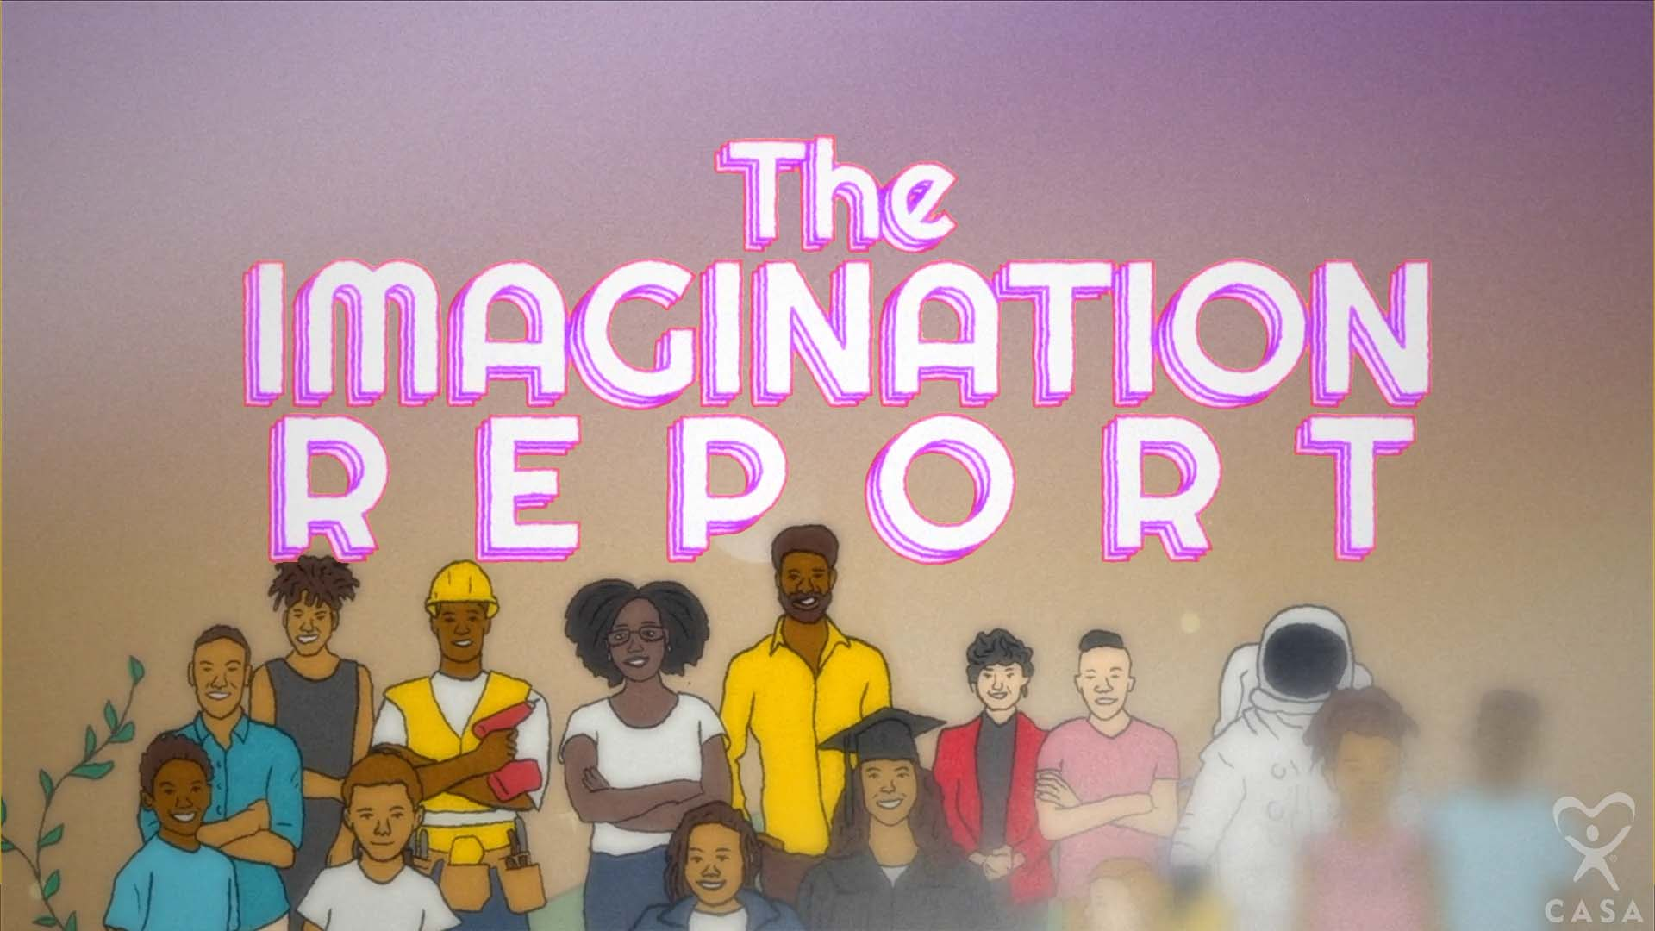
#MyImaginationReport –
Social Media Toolkit

Below, you will find a social media toolkit with resources around the release of the Imagination Report original song and music video. These materials can be used for any promotion efforts following the official announcement from Texas CASA on Wednesday, Dec. 15. Programs are encouraged to share content via social and digital promotion on your program’s channels, newsletters and website. It is our hope that these materials will to help you amplify and increase awareness of your local CASA program.

We ask that you kindly keep all material under embargo until the music video and webpage are live. We will continue to keep you updated on the exact publication timing.

The music video can be viewed via the landing page here: https://texascasa.org/imagination-report/ (Password: IR2021) Please do not share this link or video outside of your organization.

*The password will be removed on Dec. 15.

The following resources are included:
- Topline Messaging
- Quotes
- CASA Messaging & 2021 Impact Numbers
- Sample Social Content
- Social Assets

TOPLINE MESSAGING

About The Imagination Report

Every child needs someone in their life to help their dreams flourish. It was this thought that brought together internationally renowned poet Ebony Stewart, Austin-based performers Riders Against the Storm (RAS) and Jonathan Horstmann to create an original piece meant to demonstrate the difference one person can make in a child’s life, especially when they share common community bonds. The collaborative piece called “The Imagination Report” makes its debut today via the Texas CASA website and on the organization’s social media channels to coincide with the holidays.

The music video project began when Stewart was inspired to pen her poem entitled the Imagination Report after reading a similarly named report produced in 2017 by Fatherly and New York Life. The report was commissioned to answer the question “What do kids want to be when they grow up?” and surveyed more than 1,200 children. Award-winning hip hop artists Riders Against the Storm (RAS) were moved to put Stewart’s words to music and later the words and music were brought to life in an animated video produced by Jonathan Horstmann and Texas CASA.

About Riders Against the Storm and Ebony Stewart

Riders Against the Storm (RAS), a husband and wife duo based in Austin, Texas, are the very essence of the cultural phenomenon known as hip hop. Understanding that art and performance are keys to transforming the individual spirit, they have built institutions that aid in this mission, including Body Rock ATX, now running 10 years strong, and RAS Day music festival, a standout of the ATX live music scene for 6 years. Within their music, and central to their purpose as creators, is an upholding of the culture's spiritual integrity, and a contagious celebration of the magic of creating something from ‘nothing.’

Ebony Stewart is an international touring poet and performance artist. Her work speaks to the black experience, with emphasis on gender, sexuality, womanhood, and race, with the hopes to be relatable, remove shame, heal minds, encourage dialogue, and inspire folks in marginalized communities. As one of the most decorated poets in Texas, Ebony is a respected coach & mentor, one of the top touring poets in the country, and a Woman of the World Poetry Slam Champion.

QUOTES
“When I was growing up my mother told me that anything I wanted to do I could. It was a belief she instilled me that I would call upon again and again whenever I encountered opportunities or faced challenges,” said Vicki Spriggs, Texas CASA CEO. “Through the ‘Imagination Report,’ we want all children to have the same opportunity to hear the voice of someone saying they believe in them and in their dreams. Every child deserves to have this gift. While every child who needs a CASA to serve as this voice in their life deserves to have one.”

“It’s important to have a mentor in your life and to have someone to encourage you,” said Ghislaine “Qi Dada” Jean, cofounder of Riders Against the Storm. “We really hope that those who hear and see the ‘Imagination Report’ will be moved to want to support a youth in this way by becoming a CASA.”

CASA MESSAGING
About The CASA Network & The Role of CASA Volunteers

The CASA model stands as an innovative nonprofit partnership with the State of Texas that brings out the best in our fellow Texans through selfless service to their communities, and efficiently leverages public funding to support Texas’ most vulnerable children.

CASA supports children and families involved in the child welfare system.

CASA increases the well-being of the children in foster care.

CASA is of, and for, the community.

CASA volunteers stay by a child’s side throughout the case, advocating first for reunification when safe and possible.

A CASA volunteer works to:
- Identify and address risks to the child’s safety and well-being,
- Identify supportive people in the child’s life that CASA can work with to promote safety and well-being for the child during their time in foster care,
- Ensure appropriate physical and mental health assessments are completed and that the child’s needs are understood by the family and everyone involved in the case through a trauma-informed approach, and
- Verify educational assessments are completed and educational supports are in place.

2021 IMPACT NUMBERS

72 Local CASA programs
219 Texas counties serviced
11,066 CASA volunteers
29,229 Children served by CASA

SAMPLE SOCIAL CONTENT

Below is recommended social media content to be used as a guide. Content can/should be used across platforms.

Accounts to Follow & Tag
Be sure to follow Texas CASA’s and the artists’ accounts.

- Texas CASA Facebook: https://www.facebook.com/texascasainc
- Texas CASA Instagram: https://www.instagram.com/texascasa/
- Texas CASA Twitter: https://twitter.com/TexasCASA
- Riders Against the Storm Instagram: https://www.instagram.com/rashiphop/ (@rashiphop)
- Ebony Stewart: https://www.instagram.com/gullyprincess/

Hashtags
As you create your own unique content, here are the relevant handles and hashtags.

Key stakeholder accounts: @TexasCASA @rashiphop @gullyprincess
Key Hashtags: #MyImaginationReport

Please tag these accounts as relevant in your posts and use the hashtag throughout. Lastly, we do recommend liking, retweeting, and sharing content posted by Texas CASA, and other CASA programs. We also recommend reaching out to any influencers in your network or organizational partners, asking them to engage with or reshare social posts to help maximize reach. You can find additional resources for influencers later in this toolkit.

Below is suggested wording for posts on Facebook, Instagram and Twitter along with the recommended videos and links. Please follow these instructions if you have issues opening the Dropbox links:
- Right click on the hyperlink
- Click “Copy Hyperlink.”
- Open a new tab on your browser (Firefox, Chrome, etc.)
- Right click on the URL bar and select “Paste” or “Paste and Go.”

Post 1
Facebook/Instagram:
New release! International poet, Ebony Stewart and husband-and-wife hip-hop duo, Riders Against the Storm, collaborated to create The Imagination Report exclusively for Texas CASA and the CASA network. This project includes an original song, poem and music video. Check out the full video [below or in link in bio]! Do you want to open doors for children and families in crisis? Learn more by visiting BecomeACASA.org today.

Twitter: New release! International poet, Ebony Stewart and hip-hop duo, Riders Against the Storm, collaborated to create The Imagination Report exclusively for Texas CASA and the CASA network. Check it out!

Recommended Assets:
- Facebook:
  - Upload music video file OR
  - Link to landing page: https://texascasa.org/imagination-report/
- Instagram:
  - Upload clip to feed AND
  - Include link in bio to https://texascasa.org/imagination-report/
- Twitter:
  - Link to Vimeo video
  - Link to landing page: https://texascasa.org/imagination-report/

Post 2:
Facebook/Instagram:
Based on Ebony Stewart’s original poem comes this music video, The Imagination Report! Riders Against the Storm wrote and performed this song exclusively for Texas CASA and the CASA network. Together, we can all climb any mountain, rise up and stand tall. Join the dedicated members of our community, CASA volunteers, as we work to open doors for children and families involved in the child welfare system. Watch the full video [below or in link in bio].

Twitter: Together, we can all climb any mountain, rise up and stand tall. Join the dedicated members of our community, CASA volunteers, as we work to open doors for children and families involved in the child welfare system. Watch the full video!

Recommended Assets:
- Facebook:
  - Upload music video file OR
  - link to landing page: https://texascasa.org/imagination-report/
- Instagram:
  - Upload clip to feed AND
  - include link in bio to https://texascasa.org/imagination-report/
- Twitter:
  - Link to Vimeo video OR
  - Link to landing page: https://texascasa.org/imagination-report/

Post 3:
Facebook/Instagram:
Texas CASA just released a new original song produced exclusively for the CASA network – The Imagination Report! Husband-and-wife hip-hop duo, Riders Against the Storm, collaborated with international poet, Ebony Stewart, to create this project with an original song, poem and music video. Every child deserves to open up their imaginations and thrive, dedicated CASA volunteers work to ensure this continues while they are in the child welfare system. Watch the full video [below or in link in bio].

Twitter: Texas CASA just released a new original song produced exclusively for the CASA network – The Imagination Report! Hip-hop duo, Riders Against the Storm, collaborated with international poet, Ebony Stewart, to create this project with an original song, poem and music video. Check it out and share!

Recommended Assets:
- Facebook:
  - Upload music video file OR
  - link to landing page: https://texascasa.org/imagination-report/
- Instagram:
  - Upload clip to feed AND
  - include link in bio to https://texascasa.org/imagination-report/
- Twitter:
  - Link to Vimeo video OR
  - Link to landing page: https://texascasa.org/imagination-report/

SOCIAL ASSETS
Here are personalized assets for your use on Twitter, Facebook, and Instagram.

https://www.dropbox.com/sh/bavr22czg5opp0n/AAA1NfxzmfmRGGDQy4maBX3ta?dl=0

Please follow these instructions if you have issues opening the Dropbox links:
- Right click on the hyperlink
- Click “Copy Hyperlink.”
- Open a new tab on your browser (Firefox, Chrome, etc.)
- Right click on the URL bar and select “Paste” or “Paste and Go.”

