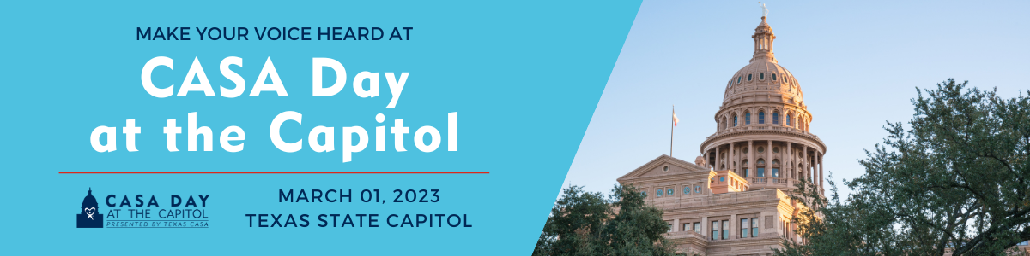

CASA Day at the Capitol 2023 Agenda
8:00 AM-9:00 AM | CHECK-IN & BREAKFAST
Legislative Conference Center (Extension Room E2.002)
8:30 AM-9:00 AM | WELCOME REMARKS
Auditorium (Extension Room E1.004)
Vicki Spriggs, Texas CASA CEO
Amanda Arriaga, Texas CASA General Counsel & Chief External Relations Officer
9:00 AM-4:30 PM | LEGISLATIVE OFFICE VISITS
Make sure you have your Capitol Day folders and leave behinds from check-in.
9:30 AM-10:00 AM | GROUP PHOTOGRAPH
Central Court Open-Air Rotunda (Lower floor of Extension Building E2)
Please arrive at least 5 minutes early for the group photo.
10:00 AM-12:00 PM | CASA DAY AT THE CAPITOL RESOLUTIONS
House & Senate Galleries (Third Floor 3W2 & 3E5)
The House convenes at 10:00 AM and the Senate convenes at 11:00 AM. Attendees can attend one or both Capitol Resolutions.
12:00 PM-1:30 PM | LUNCH
Legislative Conference Center (Extension Room E2.002)
For attendees who reserved box lunches online in advance.

