CALMING SENSORY BOTTLE
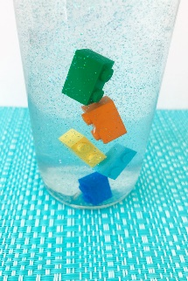
With just two simple ingredients that create the flow, this is easy to make but please be sure to read the directions carefully and to test your bottle well before sealing.
You will need:
- Clear hair gel
- Warm water
- A tall bottle
- Lego 2 stud bricks
- Fine glitter
- Super glue or tape to secure lid (optional)
- To make:
1. Combine 1 part hair gel to 6 parts warm water. Let cool completely and settle.
- 2. Pour gel/water mix into the bottle.
- 3. Add a little fine glitter and your Lego bricks. Push the bricks below the surface to remove any air bubbles.
- 4. Fill the bottle right to the very top with the remaining mixture.
- 5. Put on lid, shake vigorously, and test your bottle. If the bricks fall too slowly, empty the mixture back into a bowl and add a little more warmer water. Let cool again and re-test. If the bricks fall too quickly, mix in a little more hair gel. Let settle and re-test.
6. Once you are happy with the flow of your sensory bottle, secure the lid – a waterproof glue or wide, clear packaging tape will help to keep it secure from curious little fingers.
Flip your bottle over for some slow, relaxing breathing as you watch the bricks fall…as you can see, it’s quite mesmerizing!

