Goo Bags

It’s calming too. Like a Zen sand garden for children in bright colors. Make shapes or pattens or just repeatedly crumple it. It’s different every time.
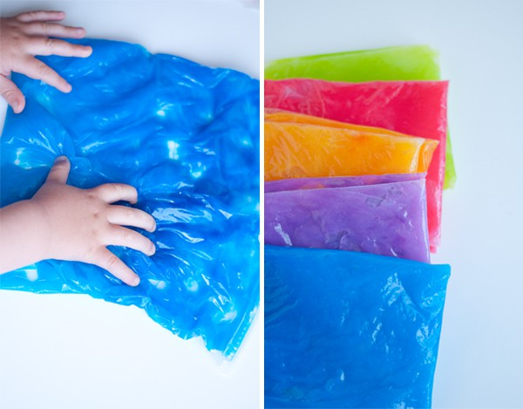
Supplies:
-1 cup cornstarch
-1/3 cup sugar
-4 cups cold water
-food coloring
-sealable bags – I used gallon freezer size
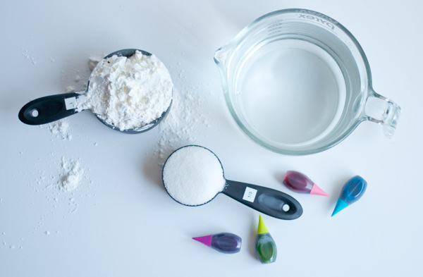
Whisk all the ingredients together in a pot over medium heat.
Continue to cook it all together, whisking frequently. As the mix thickens and solidifies, make sure to keep whisking. You will know the goo is getting to the right consistency when it changes from a white liquid to a blueish, clear goo. It will look like Vaseline.

Once it’s finished, pull it from the heat. At this point, you can add coloring. Wait until it has cooled to add it to the bags. I found it easiest to add the cooled goo to the bags and then drop in the color.
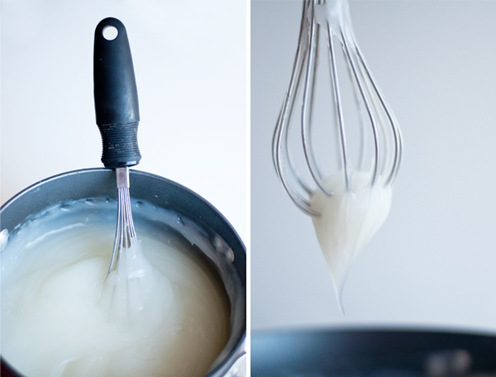

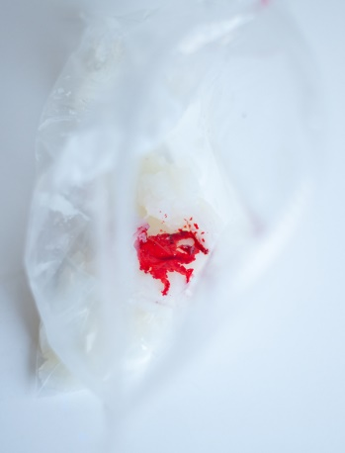
Then with a bit of squishing, the color gets mixed in. For extra security, you could place tape over the zipped opening or double bag it.
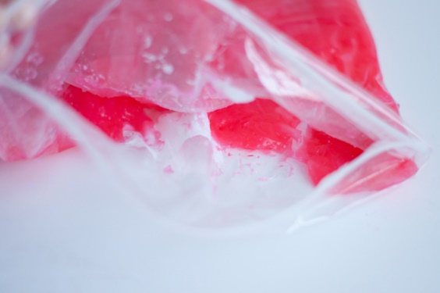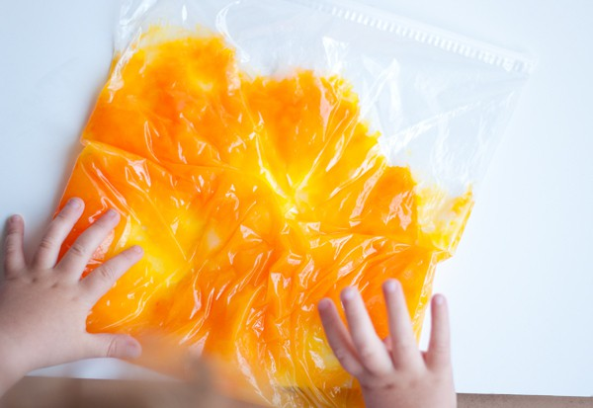

Now it’s time for little finger fun!

