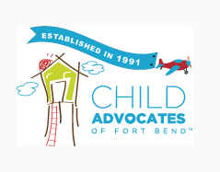

Job Well Done

Many times the end of a case is anti climatic. Case dismissed without any acknowledgment of a “Job Well Done”. Initially parents who were successfully reunified with their children, received a ‘gift” from CASA acknowledging their hard work in achieving reunification. After over a year of the family being apart from one another, we asked the family what they would like to do “as a family”. Many chose outings like the Zoo, Children’s Museum, Natural Science Museum, Chuck E Cheese, etc. We are giving parents the opportunity to celebrate with their children their success of being reunified.
As we know, many children do not return home, but are placed with relatives. These relatives have stepped up to care for children and also deserve an acknowledgment of thanks. For 2022, we have expanded our “Job Well Done” to include PMC cases.
The response from families have been overwhelming. Families are so thankful for the opportunity to spend quality family time reconnecting and strenthening bonds.

