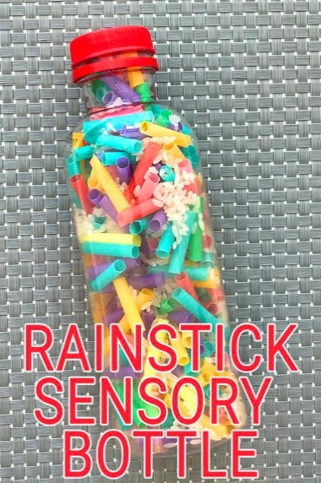
You will need:
- Clear bottle with a screw top
- Colorful plastic straws
- Rice
- Glue
Take a handful of colorful straws and cut into pieces.
Put half the straws into the bottle
Add ½ Cup of Rice
Fill the remaining straws into the bottle.
Seal the bottle.
Enjoy the sound of the rain.

