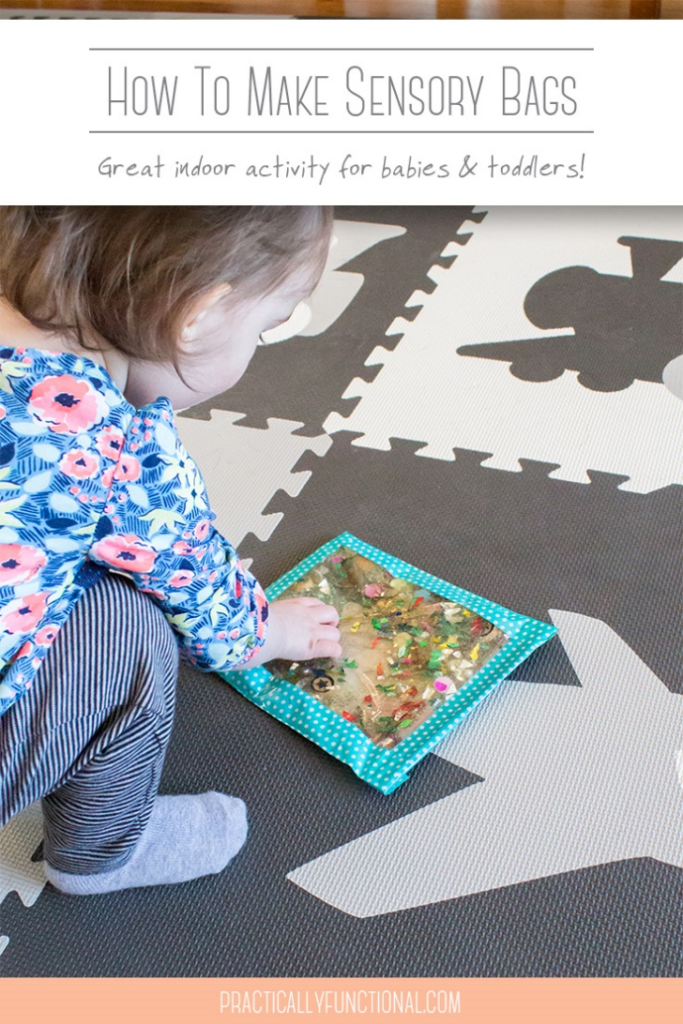

• ziploc bags
• cheap hair gel
• duct tape or packing tape
You can fill these bags with whatever you want, as long as it doesn’t have sharp edges that will puncture the bag. Here are a few of my favorite filling ideas: 1. glitter 2. confetti 3. beads 4. googly eyes 5. small plastic toys 6. pom poms 7. water beads 8. marbles 9. small foam shapes 10. beans 11. small smooth rocks 12. vase fillers 13. buttons 14. plastic letters
Fill your bag with hair gel. For a quart sized bag I use about 1 cup of hair gel (I used this LA Looks hair gel and one 20 oz bottle makes exactly two quart sized sensory bags). You don’t want to use too much or the bag will be overfilled and not as easy to squish around. Add your fillings. Again, don’t overfill the bag or it will be sensory overload! Once your bag is full, carefully squeeze all of the air out of the bag, then close the bag. Using duct tape or packing tape, seal the opening so the bag doesn’t accidentally open while your child plays. Bright colored duct tape is a great way to seal the bag securely.

