TOYS FOR YOUR CHILD’S AGE

Parents.com

Choose an Activity Mat
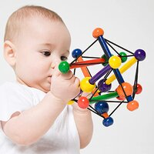

2 of 8 How They Play: 0-12 Months
For the first three months, your baby isn't able to do much more than observe her surroundings. Because her vision is still blurry, she sees bright, boldly patterned items best. "Toys don't have to be black and white so long as the colors contrast with each other," says Nora Newcombe, Ph.D., a developmental psychologist at Temple University, in Philadelphia. As your baby grows, she'll enjoy toys that engage her other senses as well. That's why so many toys are designed to promote interaction in a variety of ways: They may make a squeaking or crinkling noise, have a nubby texture, and be soft and cuddly. Infants tend to mouth toys, and textured ones can help relieve teething pain.
Top Toys:
- Brightly colored, multipatterned crib mobiles (Note: Remove from crib once your baby can sit up)
- Rattles
- Unbreakable mirrors
- Floor gyms
- Activity boards
- Soft, washable, colorful stuffed animals or dolls with a smiling face
- Small stuffed fabric balls
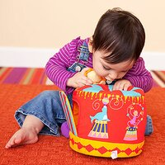

3 of 8 How They Play: 1-2 Years
"Your baby is fascinated by cause and effect and will enjoy any toy that responds to his actions and makes use of newly acquired motor skills," says psychologist Robin Goodman, Ph.D., director of NYU Child Study Center's Website, www.aboutourkids.org. For instance, he'll love toys that allow him to hit a ball with a hammer as well as toys with buttons that cause music to play or characters to pop up. Some high-tech toys for this age will name a letter, a shape, or a number when your baby presses a button. He's too young to actually learn his ABCs, but he'll still enjoy interacting with these toys and being exposed to language.
Top Toys:
Stacking rings
Nesting cups or boxes
Push- or pull-toys that make noise or have pieces that pop up or move
Hammering sets that let kids hammer pegs or balls through holes
Simple, sturdy musical instruments like tambourines, drums, or maracas
Shape sorters
Large play vehicles, such as a school bus or a fire engine, plus plastic people that ride in them
Puzzles with four or five pieces
Rubber ducks or toy boats for bathtime

4 of 8 Best Toys for Babies and Toddlers
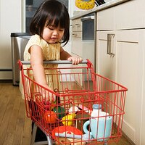

5 of 8 How They Play: 2-3 Years
Your child's play is now more purposeful, and she has the fine motor skills needed to complete a puzzle or build with blocks by herself. She'll start to enjoy pretend play that imitates the actions of people around her. She'll like high-tech toys that make real-life sounds, such as telephones that ring or dolls that talk. No matter how politically correct you are, your child will probably play in a gender-stereotypical way—at least some of the time, Dr. Newcombe says. A boy may use his dump truck to scoop up sand, while a girl might pretend to feed her doll and put it down for a nap. Boys and girls are both very active at this age and will still enjoy their push- and pull-toys. You can also introduce a ride-on toy: Start with one that your child can propel with both feet, and move up to a tricycle.
Top Toys:
- Dolls and stuffed animals
- Props for make-believe play, such as toy telephone, a tea-party set, a toy kitchen, or a doll stroller
- Ride-on toys and tricycles
- Musical instruments (especially popular are those with flashing lights on the keys that your child needs to press in order to play a tune)
- Large transportation toys with buttons to make a horn honk or a siren whistle
- Puzzles
- Construction toys that snap together
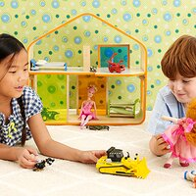

6 of 8 How They Play: 4-5 Years
There's a tremendous explosion in learning ability at this age, and it's a good time to introduce interactive educational toys that teach math and verbal skills, such as phonics boards or mini computers. "Choose toys that say positive things like 'Good job. Let's try again' instead of ones that make negative beeping noises whenever kids get an answer wrong," suggests Marianne Szymanski, president of www.toytips.com. Kids are now able to imagine that they're someone else and may fantasize about being airplane pilots, police officers, doctors, or teachers.
Top Toys:
Art supplies and craft kits
Blocks of different shapes
Electronic phonics toys
Construction sets with large pieces, such as Legos or Lincoln Logs
Puzzles of greater complexity
Action figures
Barbies
Dress-up clothes
Transportation toys, such as parking garages, airports, and train stations
Board games that don't require reading, such as Hungry Hungry Hippos, Yahtzee Jr., or Candyland
Soccer balls and basketballs
Bicycles with training wheels
- Shop interactive and educational toys

