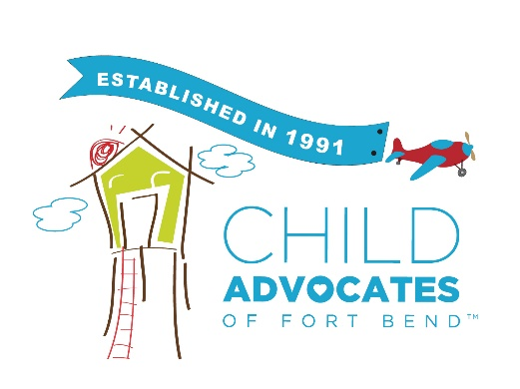
VISITATION BAG
The Visitation Bag is a tool used by Advocates to ensure a happy, healthy, productive, and positive visitation occurs at every family visit. The Visitation Bag can be any bag large enough to carry items needed for a visit. Donations can supply your bags. In the bag you can have:
- Age- appropriate toys- This enables the parent and child to play with toys on the child’s level.
- Diapers and Wipes – All babies need diaper changes. This enables a parent to meet the immediate need of their child.
- Books – Reading to your child is an essential part of attachment and bonding. It allows for touch, comfort, and one on one time. Even when a parent can not read, they can tell a story from the pictures.
- Snacks - Healthy snacks are encouraged. Sharing a snack or a meal provides an opportunity for verbal communication, story- telling, eye contact, and quiet time.
- Blanket- This encourages a parent to engage in playful interaction with their child.
- Baby Lotion – Many parents miss the opportunity to bathe their child. Bathing a child provides a child with a sense of security. A parent and child make eye contact, verbal reassurance, and gentle touch. A baby massage provides those same feelings for both the child and the parent.
- TBRI Sensory Items
- Engine Plates
By engaging in Positive Visitation Practices, a parent learns how to interact positively with their child in a safe environment. The Advocate is there to engage the parents, model for the parents and then observe. Visitations are for the parents; Advocates are there to be sure it is enjoyable and productive for all.
Parents are encouraged to bring their own “diaper bag” filled with items from home. This empowers the parents to make the visits their own.

