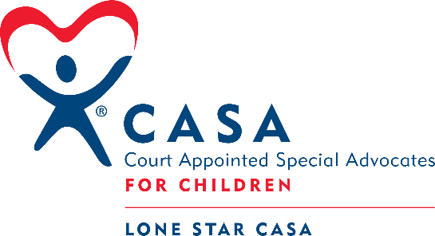
Lone Star CASA
Serving the children of Kaufman and Rockwall counties

Position: Marketing Coordinator
Category: Exempt, Full-time position
Reports to: Executive Director or Development Manager

Qualifications:
- Bachelor's Degree from an accredited college or university in marketing, communications, event management, hospitality, graphic design, or a related field preferred
- Preferred experience in at least one area of non-profit communications, email marketing platforms, press releases, or social media
- Excellent communication, writing, and organizational skills are a must
- Recognize and respect the sensitive nature of the work and maintain confidentiality.
- The ability to work cooperatively with individuals of diverse racial, economic, and cultural backgrounds.
- Experience with design work in Adobe In-Design, Adobe Illustrator, Adobe Photoshop, and Canva are preferred.
- Experience in working with computer software: Microsoft Office suite, donor management systems, social media scheduling tools, Canva, Adobe Creative Suite, and email marketing systems.
- Highly organized, self-motivated, flexible team player with strong organizational skills with ability to meet deadlines.
- Understanding and commitment to CASA’s mission, vision, and values

Summary of Responsibility:
As a Marketing Coordinator, you will be responsible for working with the team to develop and execute branding strategies that enhance our organization's image and increase brand awareness. You will be responsible for designing marketing materials, planning and scheduling content for our social media platforms and email newsletters to maintain engagement with our target audience, in addition to press releases and advertising. The Marketing Coordinator will play a key role in the development and coordination of brand management of Lone Star CASA, in addition to ensuring the high integrity of Lone Star CASA's public image.

Essential Duties and Responsibilities include the following. Other duties may be assigned.

Social Media, Email Marketing, and Communications
- Develop and execute marketing plans and campaigns to support organizational goals and objectives.
- Collaborate with internal team members to ensure cohesive and effective marketing messaging and materials
- Conduct market research and analyze data to identify audience needs, preferences, and trends to inform marketing strategies
- Coordinate various marketing initiatives, including email marketing, social media, advertising, events, and content marketing
- Monitor and report on the effectiveness of marketing campaigns using metrics such as open rates, click rates, and ROI
- Maintain and update marketing calendars and budgets to ensure timely and effective execution of marketing initiatives each month
- Coordinate the production and distribution of marketing materials, such as brochures, flyers, and other promotional items
- Prepare a monthly social media, email marketing, and communications calendar
- Cultivate and manage social media presence and content, as well as respond to all messages
- Create monthly external e-newsletters to the community, stakeholders, donors, and volunteers using an email marketing platform.
- Prepare and circulate regular and periodic press releases to local media outlets.

Design and Program Support
- Design and produce photographic or video marketing material as needed
- Design printed materials for events, programs team needs, or volunteer appreciation and support.
- Work in partnership with the Executive Director and Development Chair of the Board to develop all marketing materials for CASA, including brochures, fact sheets, handouts, annual reports, training, and advocacy resources, board resources, etc.
- Support the development and maintenance of the company's website and other digital properties.
- Design captivating and effective ads for social media and print marketing initiatives.

Events:
- Plan and attend public awareness and/or recognition events, including outreach and recruitment opportunities.
- Work to create an event marketing action plan, including timelines, marketing, and fundraising communications, and who is responsible for each task.
- Work collaboratively to develop all marketing and communications for advertising of the event and for the day of the event.

Conditions of Employment
- Schedule includes regular office hours and some evening and weekend work, requires flexibility and availability
- Must have daily transportation
- Must pass all background checks
- Ability to sit and type at computer for at least 7 hours per workday
- Ability to lift 15-25 pounds for fundraising events
- Occasionally carry out or assist with other duties not listed on this job description

Lone Star CASA is an "equal opportunity employer." The employer will not discriminate and will take "affirmative action" measures to ensure against discrimination in employment, recruitment, advertisements for employment, compensation, termination, upgrading, promotions, and other conditions of employment against any employee or job applicant on the bases of race, creed, color, national origin, or sex.

Staff Name (please print) Staff Signature Date

